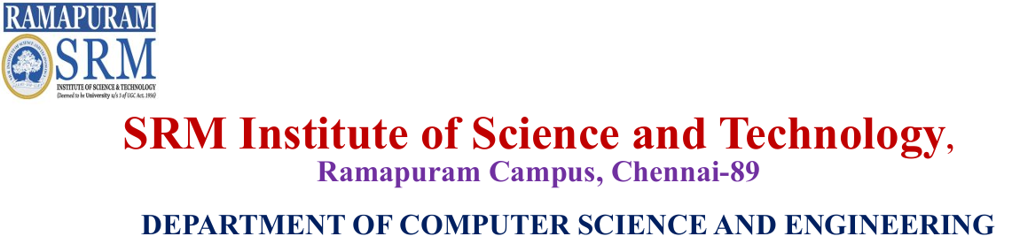
Railway Management System
Java Full Stack, OOPS, DS, DBMS, Networks

K.V.MEGHAVRDHANA- RA2411026020374
HARSHAVRDHAN - RA2411026020377
IRFAN - RA2411026020381 Mr.Mohan Kumar
NIKHIL GOWTHAM - RA2411026020388 Assistant Professor

 AGENDA
- Abstract
- Introduction
- Objective
- Scope
- Architectural Diagram
- Flow Diagram
- List of Modules
- References

 ABSTRACT
- The Railway Ticket Booking System is a Java- centric application designed to simulate real- world railway reservation operations. The system focuses on
implementing core business logic such as seat allocation, ticket booking, cancellation, RAC, and waiting list
management using Java. This project emphasizes Object- Oriented Programming concepts and provides students with hands-on experience in solving real- world problems through backend-focused application development.

 INTRODUCTION

Railway reservation systems are complex and require efficient handling of passenger data, seat availability, and ticket status. In many academic projects, the focus is placed on frontend design rather than understanding backend logic. This project aims to bridge that gap by developing a Railway Ticket Booking System where all processing and decision-making logic is handled using Java, with only minimal UI support.

 OBJECTIVE

- To design a Java-based railway ticket booking system
- To implement real-world reservation logic
- To manage confirmed tickets, RAC, and waiting list
- To demonstrate effective use of OOPS concepts
- To provide a simple and understandable system for academic evaluation

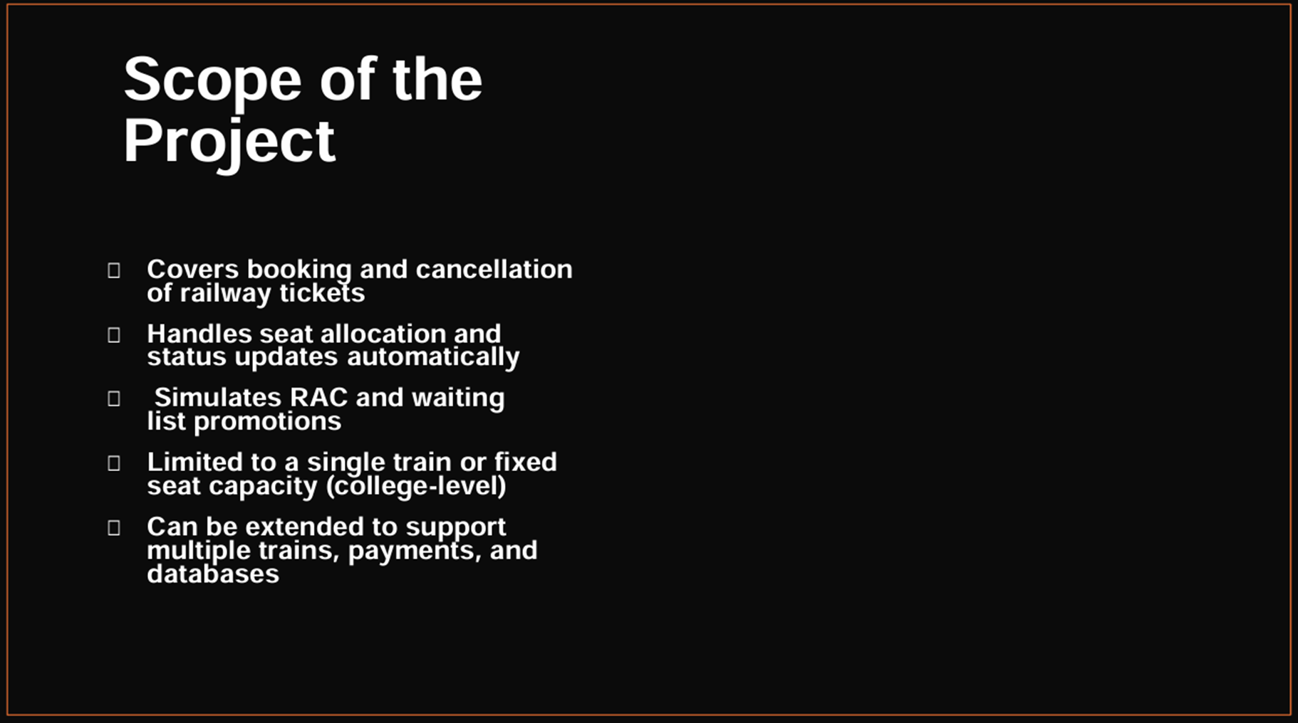
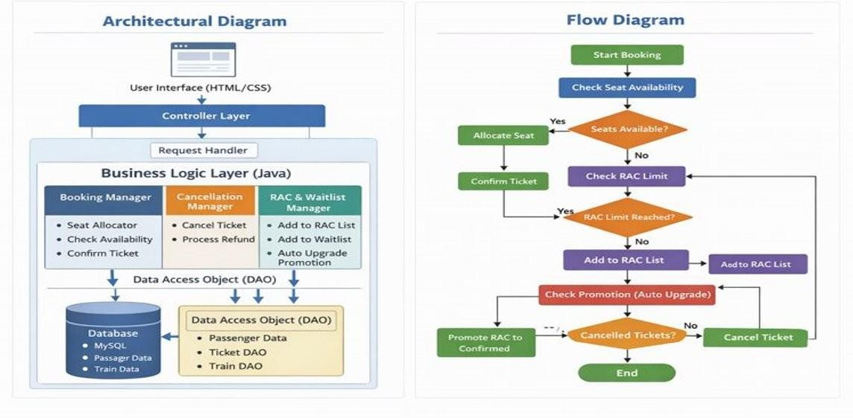
Architectural Diagram & Flow Diagram



List of Modules

    - User Module
    - Passenger Module
    - Ticket Booking Module
    - Seat Allocation Module
    - RAC Management
Module
    - Waiting List Module
    - Cancellation Module


Reference

- Train Ticket Reservation System – Reservation site with schedule, seat availability, admin panel. GitHub: Train Ticket Reservation System GitHub
- Railway Management (Python + MySQL + Tkinter) – Desktop
app with login, booking features. GitHub: Python‑based Railway Management System GitHub
- Railway Management (Java) – Java GUI app for operations, scheduling and booking. GitHub: Java Railway Management System GitHub
- Railway Management (PHP + SQL) – Classic DBMS project using HTML/CSS and PHP. GitHub: PHP Railway Management

 APPLICATIONS
- Bus Reservation Management System - Ticket booking, seat allocation, cancellation, passenger records
- Metro Rail Ticketing System
  - Smart card balance, journey tracking, fare calculation
- Airline Reservation System
  - Flight booking, seat class, passenger details, cancellation
- Online Train Pass Management System

THANK YOU..

